ARM LPC2148

General description:

The LPC2141/42/44/46/48 microcontrollers are based on a 16-bit/32-bit ARM7TDMI-S CPU with real-time emulation and embedded trace support, that combine microcontroller with embedded high speed flash memory ranging from 32 kB to 512 kB. A 128-bit wide memory interface and a unique accelerator architecture enable 32-bit code execution at the maximum clock rate. For critical code size applications, the alternative 16-bit Thumb mode reduces code by more than 30 % with minimal performance penalty. Due to their tiny size and low power consumption, LPC2141/42/44/46/48 are ideal for applications where miniaturization is a key requirement, such as access control and point-of-sale. Serial communications interfaces ranging from a USB 2.0 Full-speed device, multiple UARTs, SPI, SSP to I2C-bus and on-chip SRAM of 8 kB up to 40 kB, make these devices very well suited for communication gateways and protocol converters, soft modems, voice recognition and low end imaging, providing both large buffer size and high processing power. Various 32-bit timers, single or dual 10-bit ADC(s), 10-bit DAC, PWM channels and 45 fast GPIO lines with up to nine edge or level sensitive external interrupt pins make these microcontrollers suitable for industrial control and medical systems.
ARM LPC 2148 Introduction:

The ASK 16/32-bit ARM7TDMI-S microcontroller Training board is specifically designed to help students to master the required skills in the area of embedded systems. The kit is designed in such way that all the possible features of the microcontroller will be easily used by the students. The kit supports in system programming (ISP) which is done through serial port. ASK Board has new and advance options which will give user the liberty of implementing complex logic used in the design of Embedded Systems. The development experience on the ASK Board will posed an opportunity to excel in the field of Embedded Systems.

ASK ARM Project KIT (LPC 2148)
Board Features :

- Processor: LPC2148
- 2xSerial ports(One for ISP and other for Serial Communication)
- 12.00 MHz crystal
- On board Reset Circuit with a switch.
- Dual Power supply (either through USB or using external power adapter).
- Power on LED supply.
- Three on-board voltage regulators 1.8V, 3.3V and 5V with up to 800mA current
- Extension headers for μC ports.
- Graphic LDC display interfacing port.
- USB Ports.
- CAN controller Interfacing.
- MMC/SD card interfacing.
- 8 Bit LED interfacing.
- EEPROM Interfacing.
- On board UART.
LPC2148 Chip Features:

- 16-bit/32-bit ARM7TDMI-S microcontroller in a tiny LQFP64 package.
- 8 kB to 40 kB of on-chip static RAM and 32 kB to 512 kB of on-chip flash memory.
- 128-bit wide interface/accelerator enables high-speed 60 MHz operation.
- In-System Programming/In-Application Programming (ISP/IAP) via on-chip boot loader software. Single flash sector or full chip erase in 400 ms and programming 256 bytes in 1 ms.
- Embedded ICE RT and Embedded Trace interfaces offer real-time debugging with the on-chip Real Monitor software and high-speed tracing of instruction execution.
- USB 2.0 Full-speed compliant device controller with 2 kB of endpoint RAM.
- Single 10-bit DAC provides variable analog output (LPC2142/44/46/48 only).
- Two 32-bit timers/external event counters (with four capture and four compare channels each), PWM unit (six outputs) and watchdog.
- Low power Real-Time Clock (RTC) with independent power and 32 kHz clock input.
- Multiple serial interfaces including two UARTs (16C550), two Fast I2C-bus (400 kbit/s),
- SPI and SSP with buffering and variable data length capabilities.

Brief history of ARM:

- ARM is short for Advanced Risc Machines Ltd.
- Founded 1990, owned by Acorn, Apple and VLSI
- Known before becoming ARM as computer manufacture Acorn which developed a 32-bit RISC processor for it’s own use (used in Acorn Archimedes)
Why ARM here:

- ARM is one of the most licensed and thus widespread processor cores in the world
- Used especially in portable devices due to low power consumption and reasonable performance (MIPS / watt)
- Several interesting extensions available or in development like Thumb instruction set and Jazelle Java machine
ARM:

- Processor cores: ARM6, ARM7, ARM9, ARM10, ARM11
- Extensions: Thumb, El Segundo, Jazelle etc.
- IP-blocks: UART, GPIO, memory controllers, etc

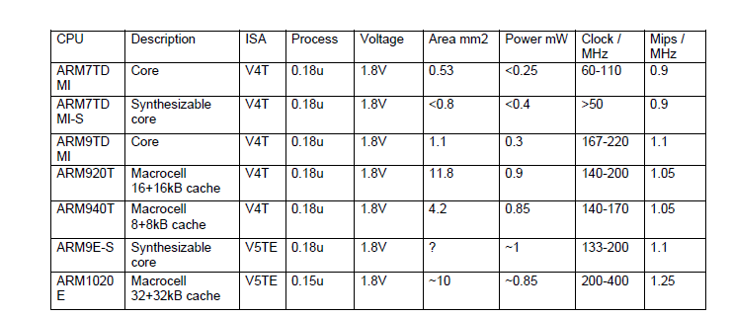

ARM architecture:

- ARM:
- 32-bit RISC-processor core (32-bit instructions)
- 37 pieces of 32-bit integer registers (16 available)
- Pipelined (ARM7: 3 stages)
- Cached (depending on the implementation)
- Von Neuman-type bus structure (ARM7), Harvard (ARM9)
- 8 / 16 / 32 -bit data types
- 7 modes of operation (usr, fiq, irq, svc, abt, sys, und)
- Simple structure -> reasonably good speed / power
- consumption ratio

ARM as a standard component:

- Even tough ARM is mostly used as a processor core in SoC and other ASICs have some manufacturers brought ARM based standard products to market
- Examples of manufacturers: Atmel, Cirrus Logic, Hyundai, Intel, Oki, Samsung, Sharp • Most of the products are based on 7TDMI-core, some to 720Tand 920T-cores
- ARM + FPGA: Altera and Triscend
- In addition, there are a number of ASSP (Application Specific Standard Product) -chips available for example to communication applications (Philips VWS22100 = ARM7 based GSM baseband chip).

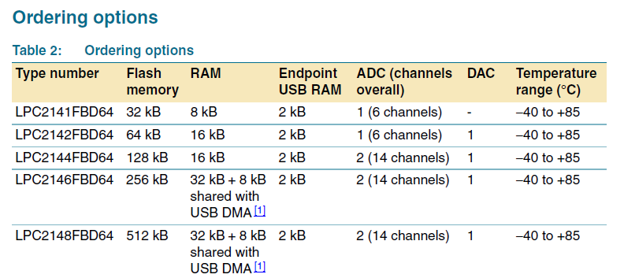

Pinning information:

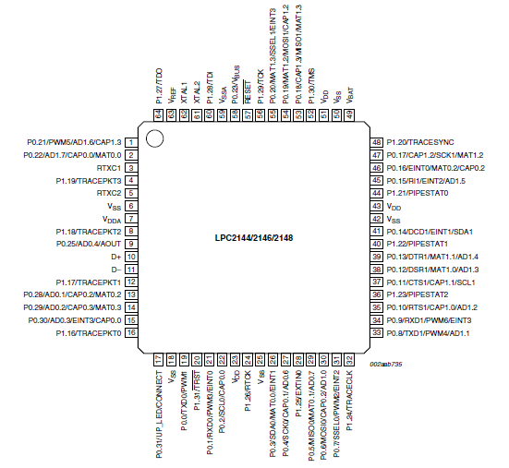

PIN DESCRIPTION
P0.0 to P0.31 : General Purpose bidirectional digital I/O’s except P0.31 is output pin
Pins P0.24, P0.26 and P0.27 are not available
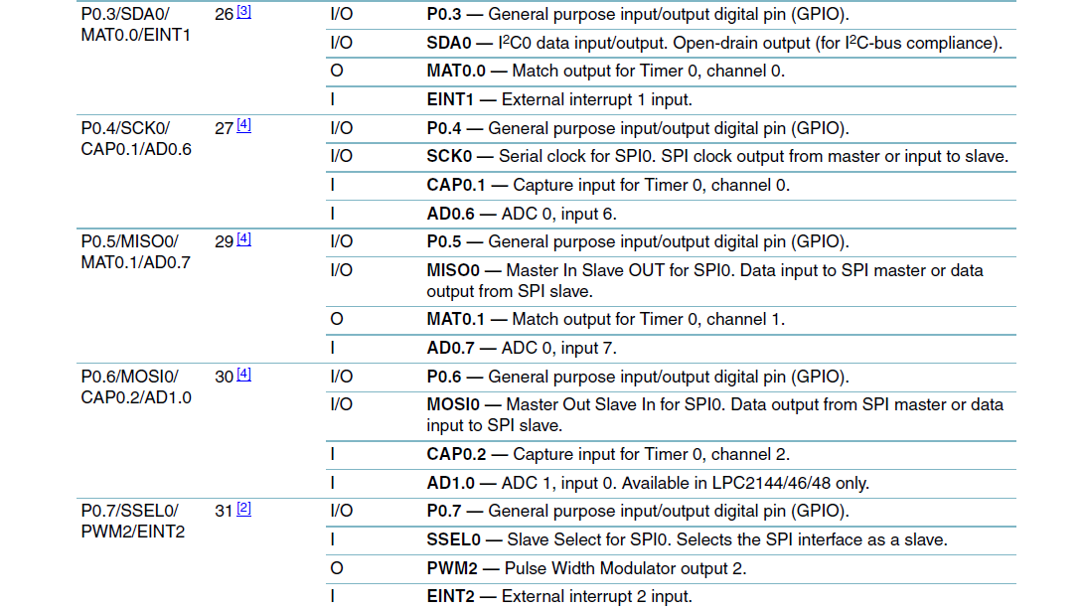
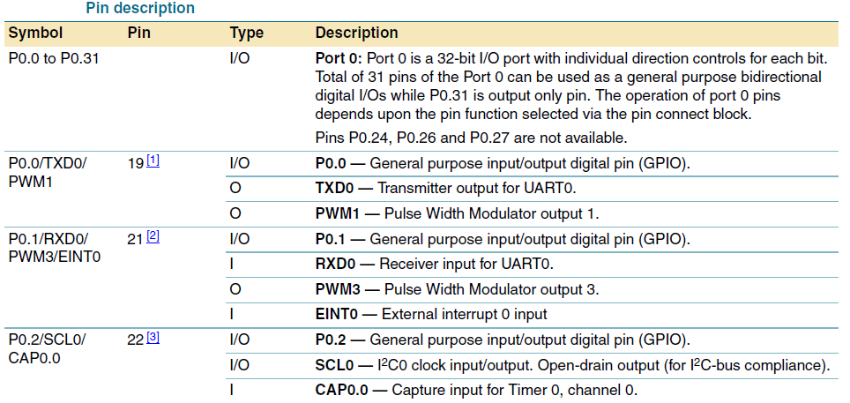

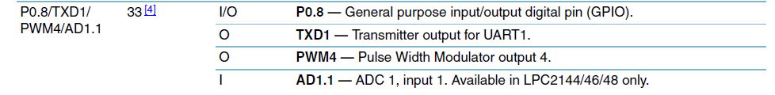
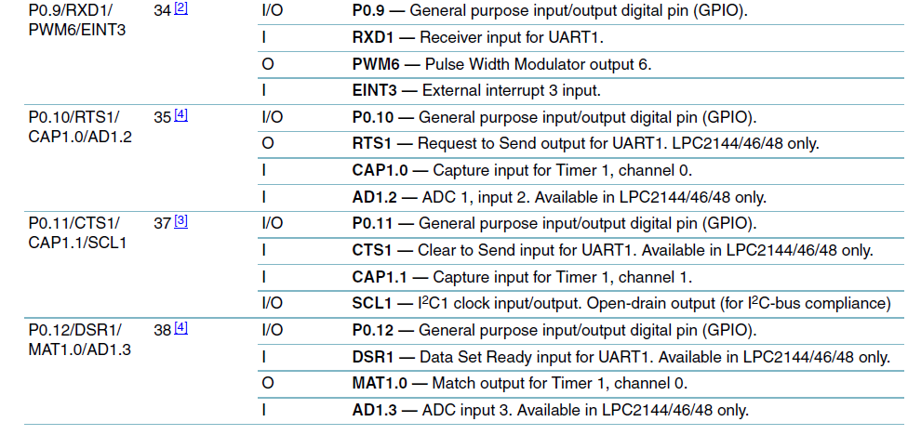
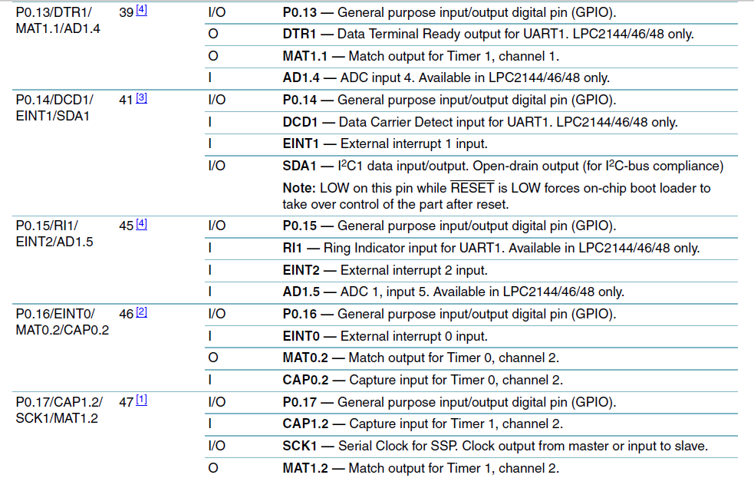
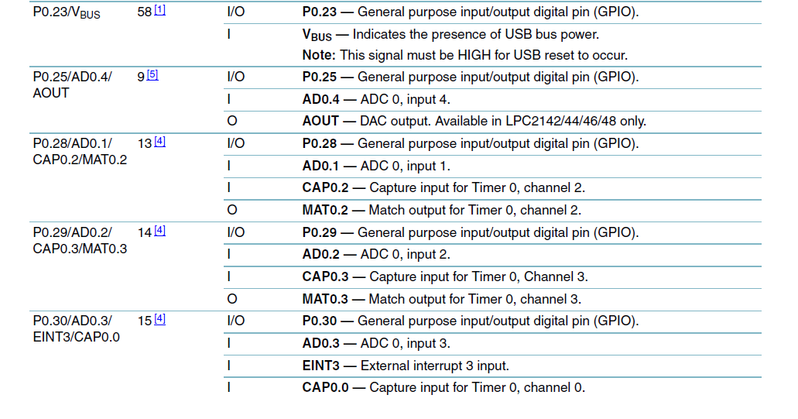
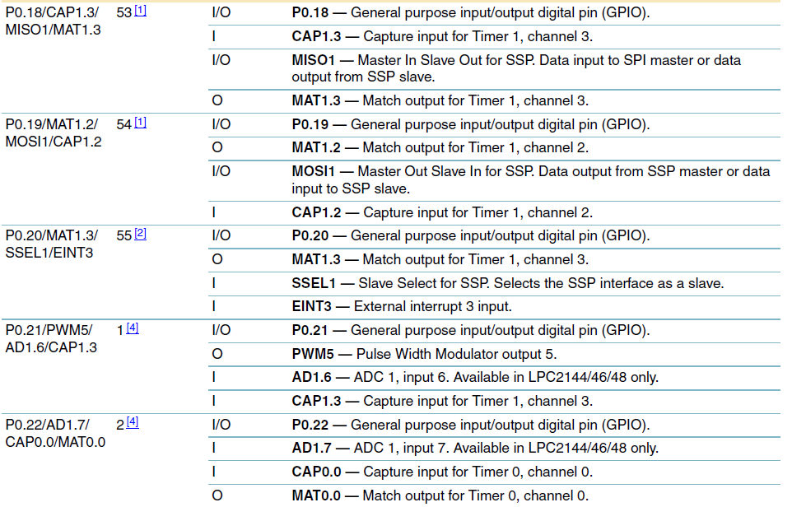

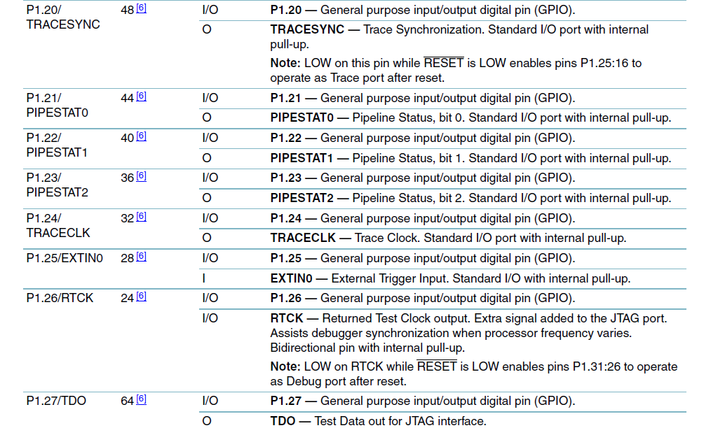
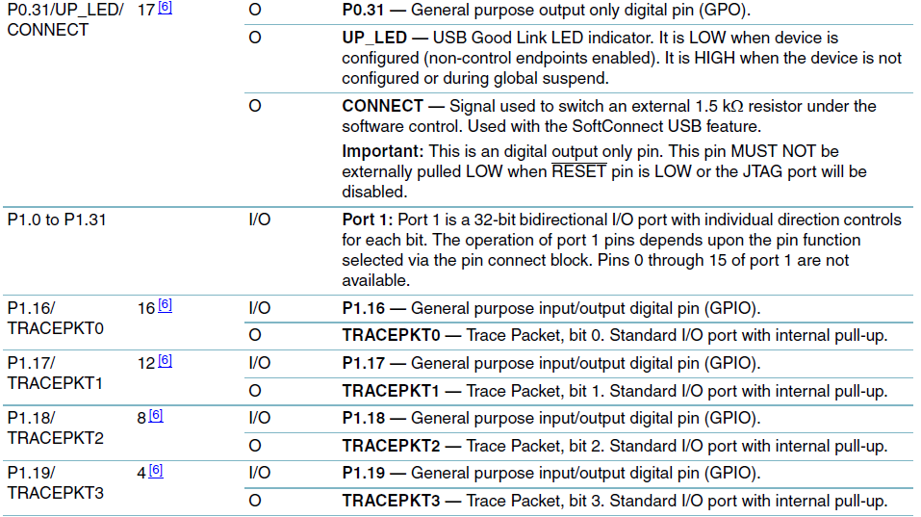

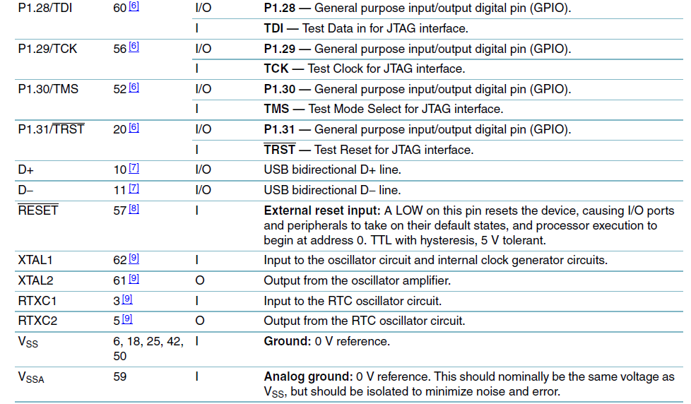
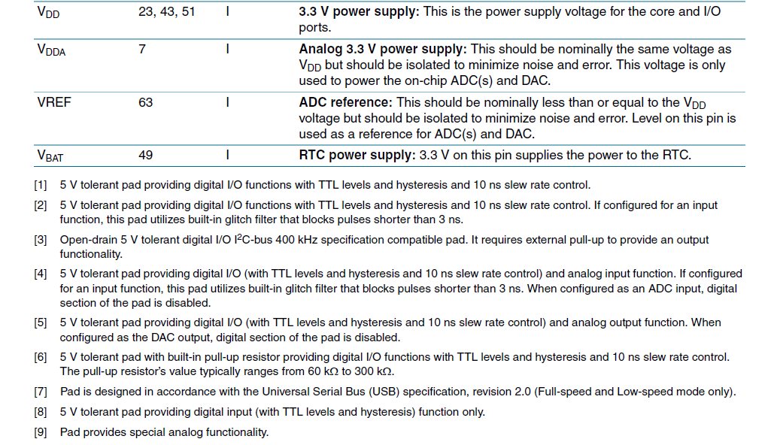

Architectural overview:

The ARM7TDMI-S is a general purpose 32-bit microprocessor, which offers high performance and very low power consumption. The ARM architecture is based on Reduced Instruction Set Computer (RISC) principles, and the instruction set and related decode mechanism are much simpler than those of microprogrammed Complex Instruction Set Computers (CISC). This simplicity results in a high instruction throughput and impressive real-time interrupt response from a small and cost-effective processor core. Pipeline techniques are employed so that all parts of the processing and memory systems can operate continuously. Typically, while one instruction is being executed, its successor is being decoded, and a third instruction is being fetched from memory. The ARM7TDMI-S processor also employs a unique architectural strategy known as Thumb, which makes it ideally suited to high-volume applications with memory restrictions, or applications where code density is an issue. The key idea behind Thumb is that of a super-reduced instruction set. Essentially, the ARM7TDMI-S processor has two instruction sets:
- The standard 32-bit ARM set.
- A 16-bit Thumb set.
The Thumb set’s 16-bit instruction length allows it to approach twice the density of standard ARM code while retaining most of the ARM’s performance advantage over a traditional 16-bit processor using 16-bit registers. This is possible because Thumb code operates on the same 32-bit register set as ARM code. Thumb code is able to provide up to 65 % of the code size of ARM, and 160 % of the performance of an equivalent ARM processor connected to a 16-bit memory system. The particular flash implementation in the LPC2141/42/44/46/48 allows for full speed execution also in ARM mode. It is recommended to program performance critical and short code sections (such as interrupt service routines and DSP algorithms) in ARM mode. The impact on the overall code size will be minimal but the speed can be increased by 30% over Thumb mode.
On-chip flash program memory:

The LPC2141/42/44/46/48 incorporate a 32 kB, 64 kB, 128 kB, 256 kB and 512 kB flash memory system respectively. This memory may be used for both code and data storage. Programming of the flash memory may be accomplished in several ways. It may be programmed In System via the serial port. The application program may also erase and/or program the flash while the application is running, allowing a great degree of flexibility for data storage field firmware upgrades, etc. Due to the architectural solution chosen for an on-chip boot loader, flash memory available for user’s code on LPC2141/42/44/46/48 is 32 kB, 64 kB, 128 kB, 256 kB and 500 kB respectively. The LPC2141/42/44/46/48 flash memory provides a minimum of 100,000 erase/write cycles and 20 years of data-retention.

On-chip static RAM:

On-chip static RAM may be used for code and/or data storage. The SRAM may be accessed as 8-bit, 16-bit, and 32-bit. The LPC2141, LPC2142/44 and LPC2146/48 provide 8 kB, 16 kB and 32 kB of static RAM respectively. In case of LPC2146/48 only, an 8 kB SRAM block intended to be utilized mainly by the USB can also be used as a general purpose RAM for data storage and code storage and execution.
Memory map:

The LPC2141/42/44/46/48 memory map incorporates several distinct regions In addition, the CPU interrupt vectors may be remapped to allow them to reside in either flash memory (the default) or on-chip static RAM. This is described in “System control”.

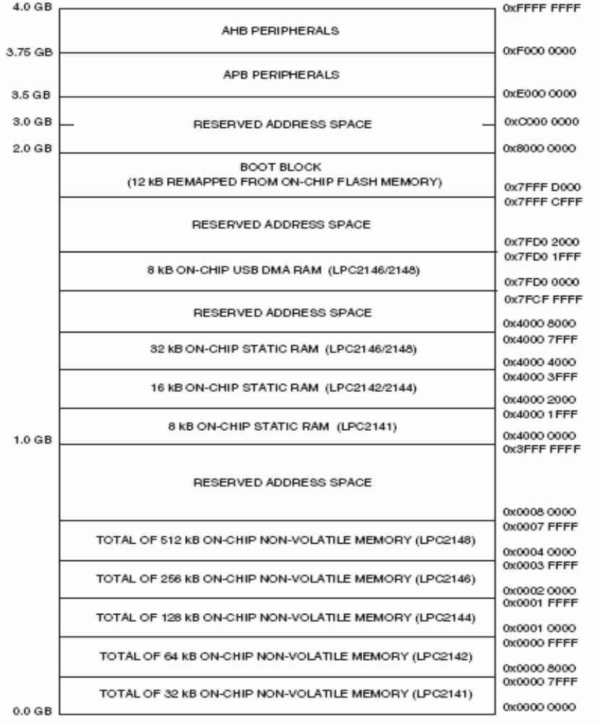

Interrupt controller:

The Vectored Interrupt Controller (VIC) accepts all of the interrupt request inputs and categorizes them as Fast Interrupt Request (FIQ), vectored Interrupt Request (IRQ), and non-vectored IRQ as defined by programmable settings. The programmable assignment scheme means that priorities of interrupts from the various peripherals can be dynamically assigned and adjusted. Fast interrupt request (FIQ) has the highest priority. If more than one request is assigned to FIQ, the VIC combines the requests to produce the FIQ signal to the ARM processor. The fastest possible FIQ latency is achieved when only one request is classified as FIQ, because then the FIQ service routine does not need to branch into the interrupt service routine but can run from the interrupt vector location. If more than one request is assigned to the FIQ class, the FIQ service routine will read a word from the VIC that identifies which FIQ source(s) is (are) requesting an interrupt. Vectored IRQs have the middle priority. Sixteen of the interrupt requests can be assigned to this category. Any of the interrupt requests can be assigned to any of the 16 vectored IRQ slots, among which slot 0 has the highest priority and slot 15 has the lowest. Non-vectored IRQs have the lowest priority.
The VIC combines the requests from all the vectored and non-vectored IRQs to produce the IRQ signal to the ARM processor. The IRQ service routine can start by reading a register from the VIC and jumping there. If any of the vectored IRQs are pending, the VIC provides the address of the highest-priority requesting IRQs service routine, otherwise it provides the address of a default routine that is shared by all the non-vectored IRQs. The default routine can read another VIC register to see what IRQs are active.

Interrupt sources:

Each peripheral device has one interrupt line connected to the Vectored Interrupt Controller, but may have several internal interrupt flags. Individual interrupt flags may also represent more than one interrupt source.
Pin connect block:

The pin connect block allows selected pins of the microcontroller to have more than one function. Configuration registers control the multiplexers to allow connection between the pin and the on chip peripherals. Peripherals should be connected to the appropriate pins prior to being activated, and prior to any related interrupt(s) being enabled. Activity of any enabled peripheral function that is not mapped to a related pin should be considered undefined. The Pin Control Module with its pin select registers defines the functionality of the microcontroller in a given hardware enviroment. After reset all pins of Port 0 and 1 are configured as input with the following exceptions: If debug is enabled, the JTAG pins will assume their JTAG functionality; if trace is enabled, the Trace pins will asume their trace functionality. The pins associated with the I2C0 and I2C1 interface are open drain.

ARM Features
Load-Store Architecture:

A load-store architecture focus on the process, i.e. reading a value by copying from the memory to the register (load instructions) or writing a value from the register to the memory (store instructions). ARM does not support memory-to-memory operations like a CISC (Complex Instruction Set Computer) machine. The processor works as follow:
- Data processing instructions: for dealing with the registers only
- Data transfer instructions: for copying data from the memory to the register or from the register to the memory
- Control flow instructions: for controlling the order of execution
ARM Processor Instruction Set:

The size of ARM processor instruction is 32-bit, excluding the 16-bit Thumb instruction set (for the microcontroller only) that has the following features:
- Support load-store architecture
- Process 3 registers at a time (2 address registers and 1 data register)
- Support various registers
- Took 1 instruction (or 1 clock cycle) to transfer and process arithmetic and logic operations.
- Is an open instruction set; more registers or data can be added

Pipelining:

An instruction cycle has 3 stages:

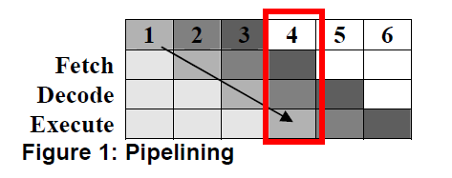
During the execution of the 1st instruction, the 2nd instruction being decode and the 3rd instruction is being fetch. See the Figure 1 below.

Pipelining

LPC2148 Technical Features CPU and Data Bus:

LPC2148 used ARM7TDMI-S as its core and two types of buses to increase the board’s performance. The modules inside are connected by the CPU high-performance bus called Advance High-Performance Bus (AHB) and the peripheral are connected by VLSI Peripheral Bus (VPB). The data between the two buses are exchange at the AHB and VPB bus connection. ARM7TDMI-S has two sets of instruction set: the 32-bit Standard and 16-bit Thumb instruction set. The used of Thumb instruction set can reduced the size of the control program up to 65% and increases the performance up to 160%
Memory:
LPC2148 has 2 types of memory :

Flash Memory 512 kb (0x0000 0000 – 0x0007 FFFF)

- 12 kb used for storing the boot loader firmware (software resided in a chip)
- 500 kb working space that can store the program or data
Static ram 40 kb (0x4000 0000 – 0x4000 7FFF)

- 32 kb for the program or data
- 8 kb for DMA when USB is in use (this space can also be used to store the program or data) Memory at the address range of (0xE000 0000 – 0xFFFF FFFF) is for the AHB and APB peripherals. Each peripheral has 16kb in size. Also, all peripheral register are aligned to 32-bit (regardless of their original size).
Memory map concepts and operating modes:

LPC2148 used the concept that each memory area has a “natural” location. Also, the bulk remains at fixed position, thus, there is no need to design code to run at different address range.
Memory re-mapping:

The Boot Block is mapped to the top of the on-chip memory space, thus, there is no need to change the location of the Boot Block or changing the mapping of the interrupt vectors. Memory space other than interrupt vector remains at fix location.
Vectored Interrupt Controller:

Vectored Interrupt Controller (VIC) receives all interrupt signals initiated. The priority of the interrupt is changeable by software. There are 3 types of interrupt request:
- Fast Interrupt Request (FIQ): Has the highest priority out of 3 types
- Vectored Interrupt Request (IRQ): Has the 2nd highest priority out of 3 types Has 16 interrupt sources in total, called slot (slot 0 has the highest priority and slot 15 has the lowest priority)
- Non-vectored IRQ: Has the lowest priority out of 3 types
Fast I/O Port:

Each of LPC2148 pins can be configured to various peripheral modules. When the values of all pins are reset, by default, it is set as input. Moreover, if the pins are configured as input/output digital, the GPIO register takes charge of the control.
Analogy to Digital Module:

This module has 2 analogy signal input from ADC0 and ADC1. ADC0 has 6 channels and ADC1 has 8 channels. The output is a 10-bit digital signal. The functional of this module is as listed below:
- Conversion process used is Successive Approximation
- Input Analog signal 0 to Voltage reference value (+3.3V)
- Sampling Rate of 400,000 per second
- Analog to Digital converted value are stored in a register

Digital to Analogy Module:

This module has 1 10-bit digital input and 1 output analogy signal. The functional of this module is as listed below:
- 10-bit conversion
- Buffer at the output
- Power-save mode supported
- The rate of conversion configuration
USB 2.0 Module:

The USB module consisted of the register interface, the serial interface engine, the endpoint buffer memory and DMA controller. The functional of this module is as listed below:

- Compatibility with USB 2.0 Full-Speed port
- Support 32 physical end-points (or 16 logical end-points)
- Support control, bulk, interrupt and asynchronous
- End-point package can be selected from software
- Size of buffer depends on the types of end-points and the size of package
- USB connection status shown on LED
- Power by bus supported
- Support DMA
- Buffer size can be doubled to support bulk end-points and asynchronous
Universal Asynchronous Receiver Transmitter (UART) Module:
2 UART ports are available: UART0 and UART1. Part of UART0 is designed to support program download through ISP process. UART1, on the other hand, is fully designed as a parallel communication port. The baud rate of both ports can be configured separately. The functional of this module is as listed below:
- FIFO buffer for receiving or transmitting 16-byte size data
- FIFO trigger point at the 1st, 4th, 8th and 14th byte
- The source of the baud rate is inside the board
- The baud rate can be configured through software
- UART1 port signal configuration is fully arranged, including DTR, DSR, CTS,
- RTS, DCD, RI
I2C Bus Module:

This module has 2 set of I2C Buses: the Clock (SCL) bus and Data (SDA). SDA’s maximum data transfer rate is 400 Kbit/s. The I2C module can be configured as a master or slave mode. It also supported multi-master and other communication devices that have different data transfer rate. In addition, the clock frequency can be also be configured.
SPI & SSP Bus Communication Module:

LPC2148 has 1 set of SPI that support 2-way communication and Synchronous Serial Peripheral (SSP) can communication with SPI, SSI 4 lines and Micro wire Bus.
Timer / Counter Module:

This module has 2 set of Timer/Counter: Timer0 and Timer1. The size of both Timer/Counter is 32-bit. The timer uses the Clock peripheral signal (PCLK) or outer source clock signal as reference. The functional of this module is as listed below:
- 2 sets of Timer/Counter 32-bit with 32 bit prescaler
- Able to use the clock signal to increment the timer. The clock source can be from the peripheral clock (PCLK) or outer source clock.
- Timer1 has 4 slots input source for detecting or capturing signal. The slots can detect a change in logic of the input signal that is use to trigger an interrupt (if enable before hand).
- 4 32-bit registers for storing comparison values
- The timer can be configured to reset itself, continuing or stop working after an interrupt occur
- An output generates a signal when the count matches or when an interrupt occur.

Watch Dog Timer:

Watch Dog Timer prevents the microcontroller from stop functioning as a result from errors. It can be configured through a 32-bit timer and enabled through software and reset through hardware control only.
Real Time Clock:

LPC2148 has a Real Time Clock in itself that uses a 3V reserved battery. Unlike other microprocessors, there is no need for an extra RTC IC. To read the RTC values, a program to access is not needed, just connect some registers and enable the RTC. Thus, LPC2148 consumes less memory space when accessing the RTC values.
PWM Signal Module:

LPC2148 has 6 channels for generating the PWM signal (the Timer generates the signal). The PCLK increment the Timer and the Master Reset register set the period of the signal. In addition, the PWN signal can be configured as active high or low, thus, it can be use to control a 3 phase motor. 2 MR register are in use: one to control the signal cycle, the other for active edge configuration. The functional of this module is as listed below:
- 7 MR registers
- MR register is in use when the timer continues to increment, stops or is reset.
- The edge of the active signal can be configured
- 32-bit Timer/Counter is used along with 32-bit prescaler
- 6 output slots for PWM signal
System Control

Crystal Oscillator:

Crystal Oscillator is the CPU clock signal generator; the range is at 1MHz to 25MHz
Phase Lock Loop (PLL):

Phase Lock Loop received an input CLK signal of the range 10MHz-25MHz then convert the range 10MHz-60MHz

Reset and Wakeup Timer:

LPC2148 can be reset in 2 ways; from the RESET button or Watch Dog Timer. Once the reset signal is initiated, the wake up timer starts. During this time, the board setup itself. If the reset signal latches longer than the time taken for the board to setup, once the signal is gone, the CPU starts immediately. However, if the reset signal latches shorter than the time taken for the board to setup, once the signal is gone, the board waits for the wake up time to finish its first loop before starting the CPU (See Figure 3).

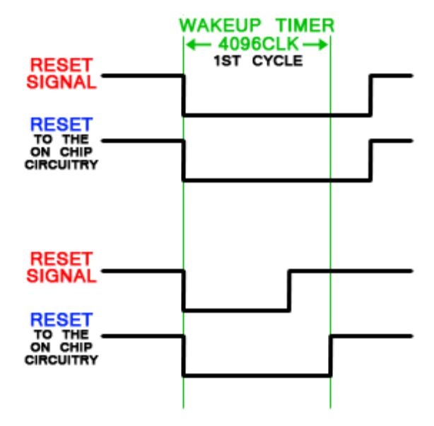
Reset and Wakeup Timing Diagram:

Low power supply / Brownout Detector If power supply is less than 2.9V, the Brownout Detector will generate an interrupt signal. However, if the power supply is less than 2.6V, the Brownout Detector (BOD) generates a signal to reset the microprocessor. Signal Separator Bus VPB bus has 2 usages: to allot the PCLK signal on the VPB bus (usually the frequency is 0.5-0.25 times lower than CPU clock) and to monitor the power on the bus, if the peripheral is not in use, that peripheral will be set on power safe mode.
Testing / Debugging Connector:

LPC2148 supports testing or debugging through JTAG port up to tracing from TRACE port. Both ports use P1 therefore, if P1 in use, P0 should be use for work purpose instead.

